Easter Sunday School Lesson
- Just for fun, have kids jump up and say “Jesus is alive!”
Introduce the Lesson
Say: Today we’re going to learn that Jesus died. But we’re also going to learn that Jesus came back to life so we can live forever! When you believe in Jesus, you can know for sure that you’ll live in heaven with Jesus forever. That’s something to look forward to!
Share
Tell kids about something you’re looking forward to in the next month or so.
Have kids tell about something they’re looking forward to in the next month or so.
Summarize
Open a Bible to Matthew 27, and say: Today is Easter! It’s a day to celebrate that we can look forward to living forever in heaven because Jesus is alive! Let’s learn more about Jesus’ death and resurrection from the Bible. The Bible is a very special book that helps us know God. One of the ways God talks to us is through the Bible. God is ready to talk to you right now. So let’s listen and talk with God.
Pray, thanking Jesus for coming back to life so we can live forever.
High-Energy Easter Game: On a Roll Relay (10 Minutes)
Supplies
- plastic eggs (1 for every 6 kids)
- file folders or pieces of card stock (1 for every 6 kids)
- upbeat music (optional) • music player (optional)
Roll an Egg
Say: In our Bible story today, things didn’t go the way Jesus’ friends thought they should go. Jesus died, and when they went to his tomb they couldn’t find his body! I’ll give you a chance to experience a little of that feeling with this wild game.
On one side of the room, give each child a file folder. Set a plastic egg in front of that child.
Say: When I say “go,” use your folder to fan the egg straight across the room to the first person in the line across from yours. You can’t touch the egg unless it rolls into a wall or gets stuck.
Begin the game. If you’d like, play music as kids play. This is a great opportunity for kids to call out encouragement to each other, cheering on their teammates. When children have successfully fanned their egg across the room, gather them again to talk.
Talk About It
Say: Those eggs didn’t always do what you wanted them to do or what you hoped they’d do!
Ask:
- In the game, how did that make you feel?
- In real life, how do you feel when things don’t go the way you’d hoped?
Say: When Jesus died, his friends may have felt [repeat some of the words kids shared, such as frustrated, disappointed, or afraid]. Things seemed out of control for them. But even though Jesus’ death and resurrection seemed out of control to Jesus’ friends, the ending was better than they could’ve imagined! Jesus is alive! We don’t have to feel hopeless because we have the hope of living forever with Jesus. Jesus came back to life so we can live forever.
Easter: Jesus Dies and Comes Back to Life (Matthew 27:27-28:10)
Taste Sour, Taste Sweet
Give each child a Sour Patch Kids candy. Say: Today’s true Bible story starts out sour like our candy. Have kids eat their candy. As they do, say: But also like our candy, our Bible story turns sweet! Let’s see how something that was sour for Jesus turned into something that was sweet for us.
Draw
Show kids the cross on the dry-erase board. Say: In Jesus’ time, a cross was used to punish really terrible criminals. When someone had committed a bad crime, that person would be killed by being hung on a cross.
There were some people who said Jesus was a criminal. That wasn’t true at all! In fact, Jesus was the only person who ever lived a perfect life. But even though he never sinned, Jesus was willing to take the punishment for the sins of everyone else.
Before they put Jesus on the cross, the governor’s soldiers did some awful things to him.
Bible Passages
Read Matthew 27:28. Ask a child to use a red washable marker to draw a robe near the cross.
Read Matthew 27:29. Ask a child to use a brown washable marker to draw a crown of thorns over the cross.
Ask:
- Tell about a time someone made fun of you. Share your own example first, and then have kids share in trios.
- How do you feel knowing people made fun of Jesus?
Read Matthew 27:30. Ask a child to use a brown washable marker to draw a stick near the cross.
Say: Next, the soldiers made Jesus carry his cross until he couldn’t carry it any longer. Then a man named Simon had to carry it the rest of the way. After that, here’s what happened.
Read Matthew 27:35. Have a child use a washable marker to draw nails on the cross.
Read Matthew 27:37. Have a child draw a sign over the cross that says “This is Jesus, the King of the Jews.”
Read Matthew 27:38. Have a child draw two more crosses, one on either side of the first cross.
Say: The other people on the crosses were real criminals. Jesus died to forgive even them! And he died to forgive us. We’ve all done wrong things or failed to do what’s right. Think about something you’ve done wrong this week. Then come up to the whiteboard and write one word that represents what you’re thinking of, or draw a picture to show what you mean. You might write “anger,” “lying,” or “left out a friend.”
Set out washable markers, and allow time for kids to come up and write on the board. Start it off by writing your own word.
Erase
Say: We aren’t criminals, but we’ve all sinned. We all needed Jesus to die on the cross for us because sin separates us from God. It’s like this.
Have kids sit several feet back from the whiteboard. Use masking tape to make a line between kids and the board. Say: Because God is perfect and we’re not, sin is like a dividing line between us and God that we can’t cross. Our sin keeps us away from God. Before Jesus died, this separation was shown by a curtain in God’s Temple. Behind the curtain was a special, super holy room where ordinary people couldn’t go because we’re all sinners.
Jesus Died on the Cross
Say: But listen to what happened to that curtain when Jesus died on the cross.
Read Matthew 27:51. Rip the masking tape up off the floor, and throw it away.
Say: We’re not separated from God anymore because Jesus died on the cross for us. And that’s not all that happened when Jesus died.
Have kids move closer to the board, crossing where the tape line was.
Use the spray bottle to spray water all over the whiteboard. All of the sins kids wrote, as well as the symbols they drew, will drip down the board. Encourage a somber atmosphere, and allow time for kids to quietly watch the water dripping. If you’d like, consider playing contemplative music. Then use a paper towel to wipe up the board so the only thing remaining will be the cross.
Say: When Jesus died on the cross, it was sad. His friends must have cried. The water that dripped down the board can remind us of those tears.
Ask:
- The day Jesus died is called “Good Friday.” If it was such a sad day, why do you think it’s called “Good Friday”? What’s good about it?
Say: When Jesus died on the cross, he made it possible for our sins to be forgiven. Just like the sins were washed away from our board, Jesus made it possible for our real sins to be washed away. That’s really good news! And the story wasn’t over…Let’s see what happened next.
Visit the Tomb
Say: After he died, Jesus was buried in a tomb—a grave in a cave.
Read Matthew 27:57-60.
Say: Jesus’ friends were sad that he died. So on Sunday they went to his tomb. They planned to put good-smelling spices on his body. But they were in for quite a surprise.
Lead kids to the tomb you made before class. Make sure everyone can see, and then lift off the blanket to reveal the bright light inside.
Say: First there was a huge earthquake. Let’s shake! Pause for kids to shake.
When they got to the tomb, it was open. An angel had rolled the stone away and was sitting on it. When Jesus’ friends looked in the tomb, Jesus wasn’t there! Let’s hear what the angel had to say.
Read Matthew 28:5-7.
Say: The angel told the women to go tell Jesus’ disciples about the empty tomb. And that’s just what they did. They spread the news that Jesus came back to life so we can live forever. And to think, we celebrate Easter today because they got the word out that Jesus is alive!
Celebrate
Say: Let’s see how quickly we can spread the news! Make a pile of unlit glow sticks by the tomb. Assign the two kids sitting closest to the pile to be the two who’ll take glow sticks from the pile. They’ll pass them to others, who’ll keep passing them until everyone has one. As kids pass the glow sticks, they’ll say the Bible point: Jesus came back to life so we can live forever. Challenge kids to pass the glow sticks quickly. When everyone has a glow stick, have kids crack them and hold them up high.
Say: Let’s wave our lights to celebrate that Jesus came back to life so we can live with him forever.
Lead kids in jumping and chanting “Jesus is alive!” as they wave their lights. Then have kids sit down.
Ask:
- What can you tell someone that you are happiest about because Jesus came back to life?
Say: When Jesus’ friends found his body missing, they cried. It was like the water dripping down our whiteboard. But their tears turned to tears of joy when they realized Jesus came back to life so we can live with him forever! It’s the best news ever!
After class, to erase the cross from the dry-erase board, draw on top of the permanent marker with a dry-erase marker. When you use a rag or eraser, it will erase both the permanent marker and the dry-erase marker.

Easter Craft: Resurrection Garden (20 Minutes)
Supplies
- plastic tablecloths
- disposable pie pans (1 per child)
- potting soil
- 3-ounce cups (1 per child)
- grass seed
- slender twigs
- string
- scissors
- pebbles
- rocks the size of the cup opening
- fake greenery (optional)
- sturdy disposable plates (optional)
Easy Prep
- Cover your craft table with plastic tablecloths. This craft can be messy!
Make a Garden
Give each child a disposable pie pan and set out the remaining supplies. Have kids follow these steps.
- 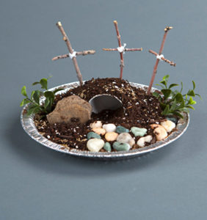
- Fill the pie pan about half full with potting soil.
- Lay the cup on its side in the middle of the pan. This will be the empty tomb.
- Put a little dirt inside the cup and press down to help it stay in place.
- Cover the cup with potting soil, pressing it down to make a firm mound.
- Sprinkle the mound of dirt with grass seed.
- Press it into the soil and top with more soil. Pat down.
- Break the twigs into three tall pieces and three shorter pieces.
- To make crosses, pair each tall twig piece with a shorter piece. Wrap string diagonally around both twig pieces to hold them together, and then tie to hold the cross pieces in place.
- Stick the three crosses into the dirt behind the tomb.
- Set a rock to the side of the tomb entrance to represent the stone that was rolled away.
- Use pebbles to make a path in front of the tomb.
- If fake greenery is available, add it around the scene to further decorate.

Talk About It
Ask:
- Close your eyes and picture Jesus’ empty tomb. How does your garden look like that? How is it different?
Say: You’ll see grass start to grow in a week or two. That grass can remind you that Jesus is alive. Jesus came back to life so we can live forever. The grass won’t live forever, but you will when you believe in Jesus.
Close
Pray: Jesus, thank you that you died for us and came back to life so we can live forever. We’re excited about living forever with you! In your name, amen.

Alternate craft:
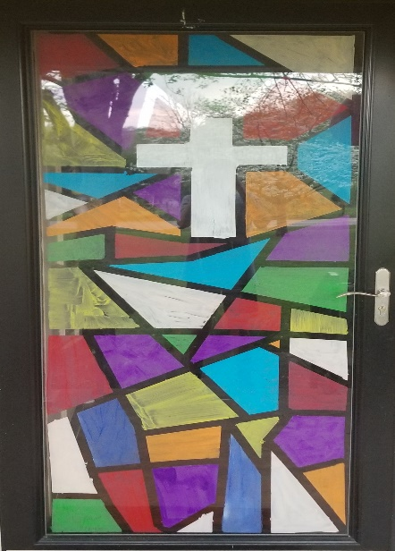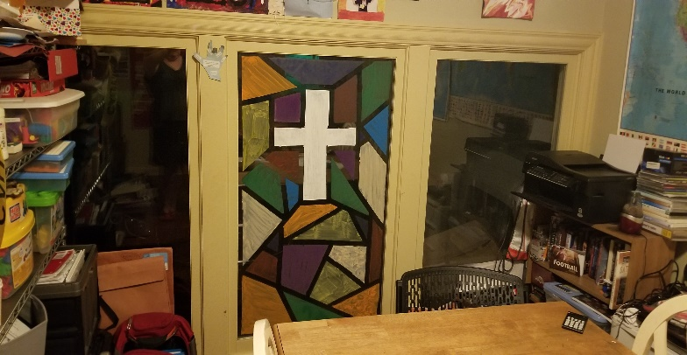

Use painters tape and washable tempera paint to have your kids create their own stained glass (washable) windows. You will not only brighten your own home but spread beauty and joy for your neighbors.

Happy Easter!!! He is RISEN!!

