Joseph in Prison craft instructions

Supplies:
- Coloring page of Joseph (included)
- Scraps of colored paper or tissue paper
- 3 pieces of colored paper
- Hole punch
- Yarn

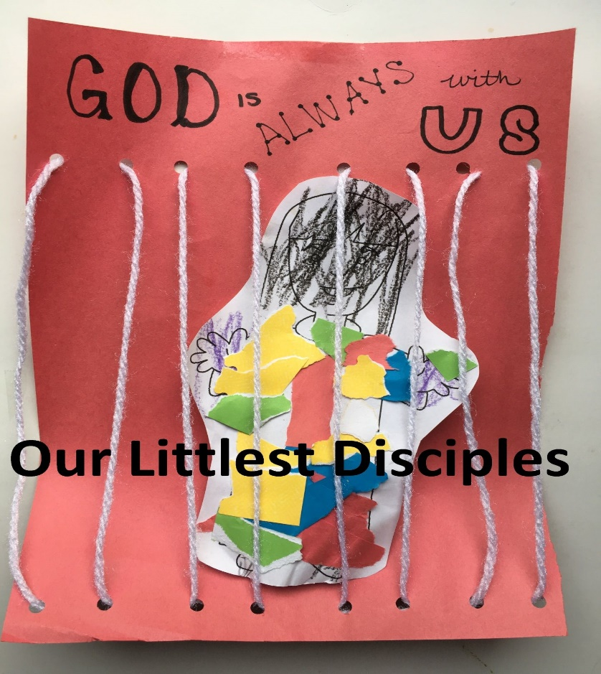

- Print the attached page and cut out the figure of Joseph.
- Color Joseph’s head, hands and feet.
- Tear colored paper or tissue paper into small pieces.
- Glue the paper onto Joseph forming his multicolored coat.
- Fold a piece of paper in half length-wise twice
- Punch two holes about 1” from the bottom and two more holes about 9” above those, as shown
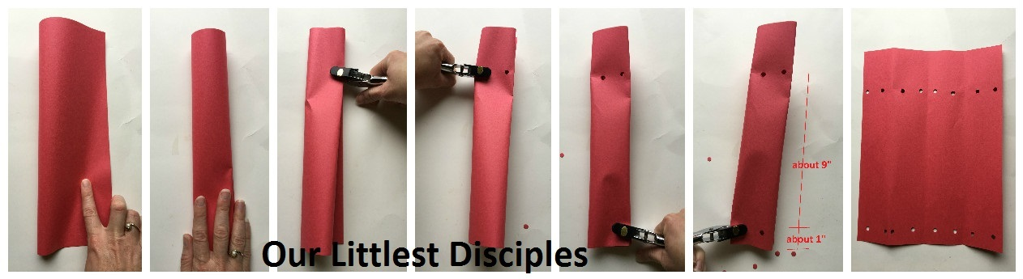
- Thread yarn through the holes as shown (pattern: top-bottom-bottom-top) to create jail bars
- Tie the yarn in place on the back
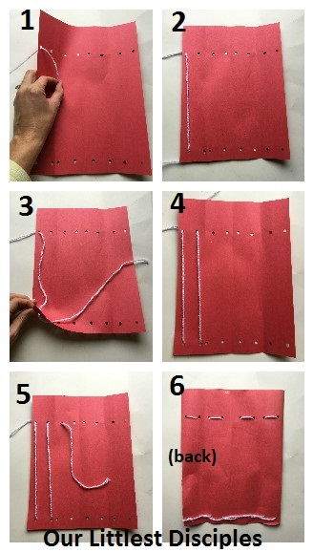
- Write on the top of the paper “God is ALWAYS with us!”
- Place the Joseph figure you created behind the yarn into the “jail” (you don’t have to glue unless you want to…because we know that Joseph did not stay in jail)

